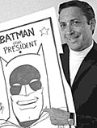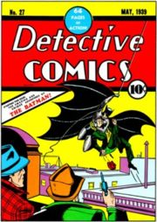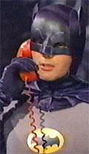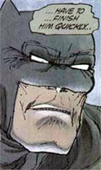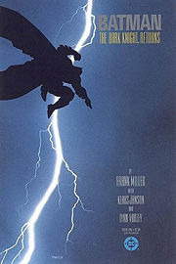

Batman: A Genealogy

Early Years: Creation
Batman begins in 1938, when the editors at the comic book division of National Publications—which would later become DC (Detective Comics)—requested more superheroes for its titles.
Figure 1:
Bob Kane
with Batman mock-up

Bob Kane responded with “the Bat-man.” Bill Finger recalls that Kane
Had an idea for a character called ‘Batman’, and he’d like me to see the drawings. I went over to Kane’s, and he had drawn a character who looked very much like Superman with kind of…reddish tights, I believe, with boots…no gloves, no gauntlets…with a small domino mask, swinging on a rope. He had two stiff wings that were sticking out, looking like bat wings. And under it was a big sign … BATMAN. (qtd from Steranko, Jim. The Steranko History of Comics 1. Reading, PA: Supergraphics, 1970. ISBN 0-517-50188-0)

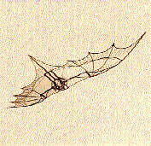
In his autobiography, Batman and Me, Bob Kane remembers that it was Finger who came up with the name of Bruce Wayne for Batman’s secret identity. He writes that “Bruce Wayne’s first name came from Robert Bruce, the Scottish patriot. Wayne, being a playboy, was a man of gentry. I searched for a name that would suggest colonialism. I tried Adams, Hancock…then I thought of Mad Anthony Wayne” (44). Kane also drew on pop culture and literature to develop the character: Movies like The Mark of Zorro (1920) and The Bat Whispers (1930) as well as characters such as Doc Savage, The Shadow, and Sherlock Holmes were influences on Kane’s development of the character’s identity and specifically, with The Mark of Zorro, with his dual identity. As for Batman’s costuming, Kane turned to the sketchbooks of Leonardo da Vinci, particularly to his sketches of his flying machine.
Figure 2:
Leonardo da Vinci sketch
of flying machine

1939:
“The Case of the Chemical Syndicate” in Detective Comics #27 (May 1939)—The first Batman story, written in pulp fiction style—a darker Batman with little or no remorse for killing.

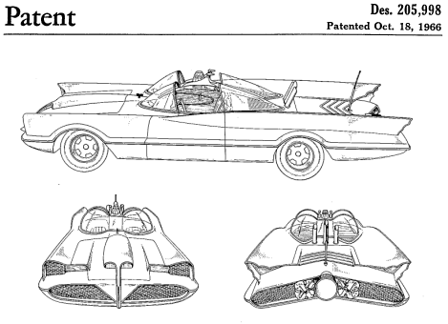
In this first year, Batman developed as a character and elements were added—lots of gadgets:
Figure 3:
Batmobile based on
Lincoln Futura concept car

DC #29: batarang
DC #31: batmobile
DC #33: Batman’s origin and reason for brooding persona—the death of his
parents after Zorro
DC #38: Robin—Finger’s idea and sales doubled; Batman was beginning to
soften at this point.

1940:
Batman received his own title.

By 1942:
The Batman myth was set; however, as Bradford W. Wright argues in Comic Book Nation (Baltimore: Johns Hopkins, 2001. ISBN 0801874505), in the years after the war, DC Comics “adopted a postwar editorial direction that increasingly de-emphasized social commentary in favor of lighthearted juvenile fantasy” (19). Thus, the movement away from the “bleak and menacing world” (Wright 59) of the 1940s Batman to the “bright and colorful” (Wright 59) landscape of a Batman that represented citizenship, responsibility, and fatherhood (Wright 59).

1950-1963: The McCarthy era’s Comics Code Authority and Development of Batman
Batman and Superman remain extremely popular even as interest begins to fade in superheroes in the 1050s. Reasons for the waning interest include the McCarthy era’s Comics Code Authority, which required comics and superheroes to meet certain requirements and regulations if they were to continue to be published. It was a censoring body. Also problematic were the criticisms of the comic book industry as well as Batman in particular by psychologist Fredric Wertham, who wrote Seductio of the Innocent in 1954. His book claimed that children would imitate the crimes that they read about in comic books and that therefore comic books corrupted our youth. He also criticized Batman for homosexual overtones, i.e., that Batman and Robin were lovers. (see Wertham Seduction of the Innocent and Bill Boichel’s “Batman: Commodity as Myth.” The Many lives of the Batman: Critical Approaches to a Superhero and His Media. Routledge: London, 1991. ISBN 0851702767, see pages 6-7).

1964-1986: New Look
By 1964, DC was planning to kill Batman. Instead, he was revamped and returned to the grim avenger of the night model.
Figure 4:
Adam West as Batman

1966-1968: New TV Animated Series
Starring Adam West, the new series is characterized by its
A handsome caped crusader,
Lots of gadgets: utility belt, batarang, batmobile
High saturation (think The Simpsons)
Words “POW!” “BAM!” exploding on the screen

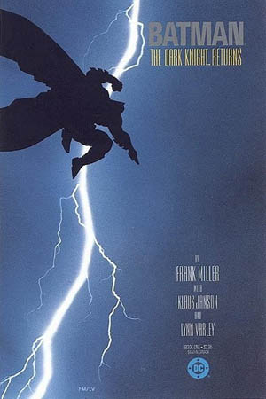
Figure 5: Frank Miller’s cover art for Batman: The Dark Knight Returns

1986- present: The Dark Knight Returns

Frank Miller and David Mazzucchelli redefined the character’s origins and overall portrayal—a film noir Batman, who was darker, older, and more cynical, was created in Frank Miller’s The DarkKnight Returns

Batman at the Movies: A Chronology
1943 The Batman. Dir. Lambert Hillyer.
1949 Batman and Robin. Dir. Spencer Gordon Bennett.
1966 Batman the Movie. Dir. Leslie Martinson.
1989 Batman. Dir. Tim Burton.
1992 Batman Returns. Dir. Tim Burton.
1995 Batman Forever. Dir. Joel Schumacher.
1997 Batman and Robin. Dir. Joel Schumacher.
2005 Batman Begins. Dir. Christopher Nolan.
2008 The Dark Knight Returns. Dir. Christopher Nolan.

Additional Image Credits
Barris, George. Batmobile based on Lincoln Futura concept car. Des. 205,998. Patented Oct. 18, 1966.
Kane, Bob, illus. “Batman” cover. Detective Comics. No. 27 (May 1939).
Miller, Frank, illus. Batman: The Dark Knight Returns. Detective Comics. No.1. 1986.

