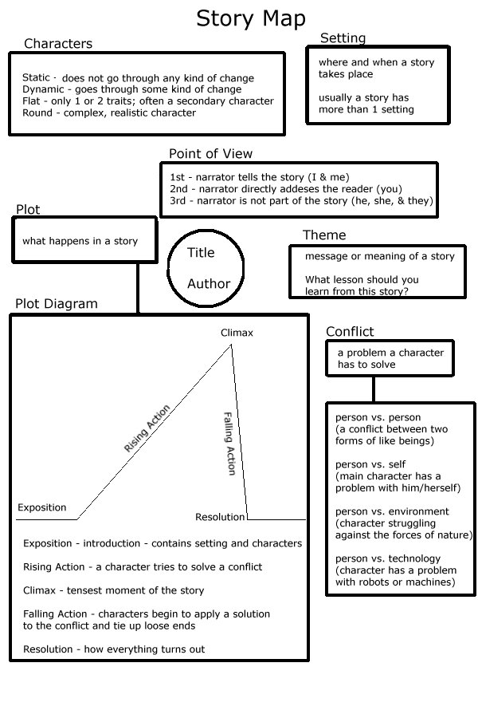

**Foreshadow:** Hint or clue as to what will happen later in the story. **Irony:** What seems to be (or should be) happening or being said is different from what is really happening or being said

**External**

**External**

**Internal**

**External**

**External**

**External**

**External**

**External**

**Symbol:**A physical object representing something more (like perhaps an idea)

**Protagonist:** Leading character, not always the hero, and rivals the antagonist.  
**Antagonist:** Strives against the main character, opposes protagonist.

**Mood:**Emotions felt while reading.

**Dialect:**The language used by a particular class, district, or group of persons.

Example

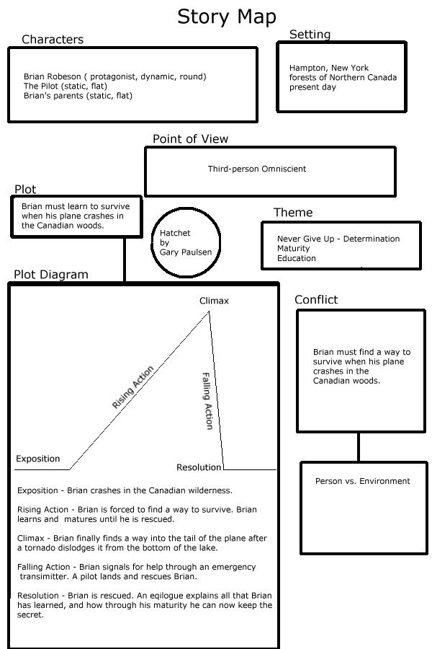

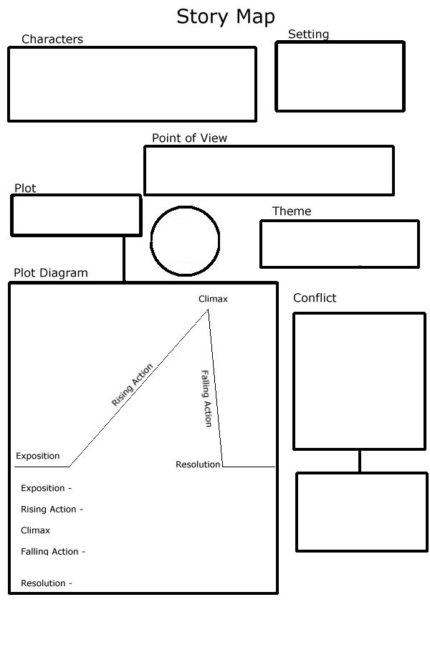

**Internal / External?**

**Symbols:**

**Foreshadow:  
  
  
Irony**

**Protagonist:**   
  
**Antagonist:**

**Mood:**

**Dialect:**